**Installation steps.**

Clone project from below repository

[**https://github.com/javabykiranojt/industrialjavapracticeproject.git**](https://github.com/javabykiranojt/industrialjavapracticeproject.git)

**Latest document about step by step installation is here refer that only.**

[**https://github.com/javabykiranojt/industrialjavapracticeproject/blob/master/testproject/project%20setup%20document%20latest.docx**](https://github.com/javabykiranojt/industrialjavapracticeproject/blob/master/testproject/project%20setup%20document%20latest.docx)

**Get Tomcat software from**

[**https://drive.google.com/drive/folders/1gg3r87CixWISEOAyvrLERhtU6YOuCK9_?usp=sharing**](https://drive.google.com/drive/folders/1gg3r87CixWISEOAyvrLERhtU6YOuCK9_?usp=sharing)

**database dump**

<https://raw.githubusercontent.com/javabykiranojt/industrialjavapracticeproject/master/testproject/src/DB/dmart%2020210208%201052_latest.sql>

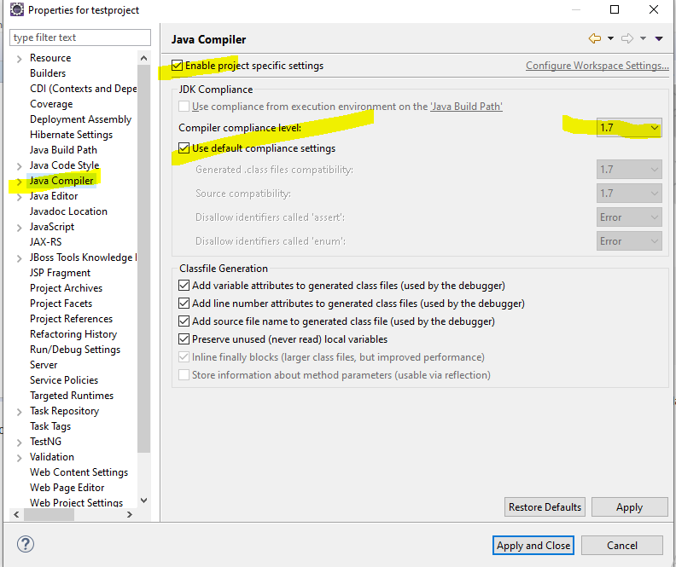

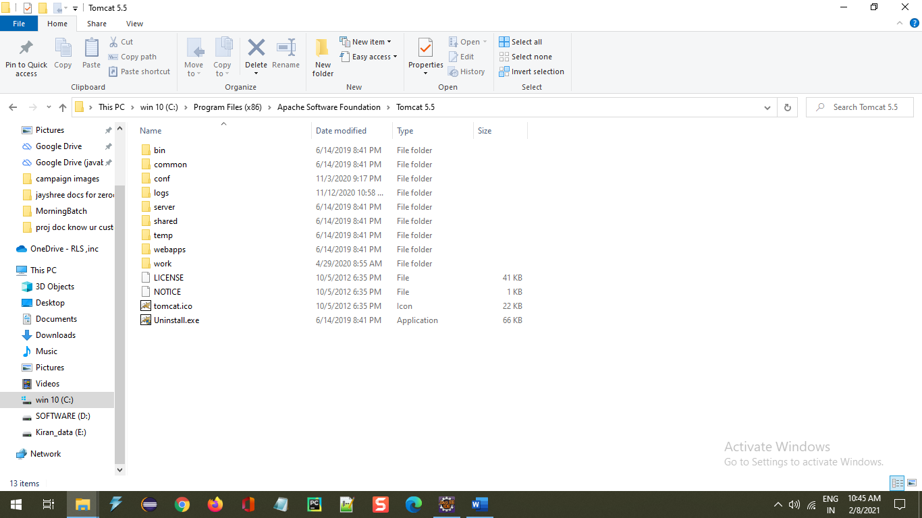

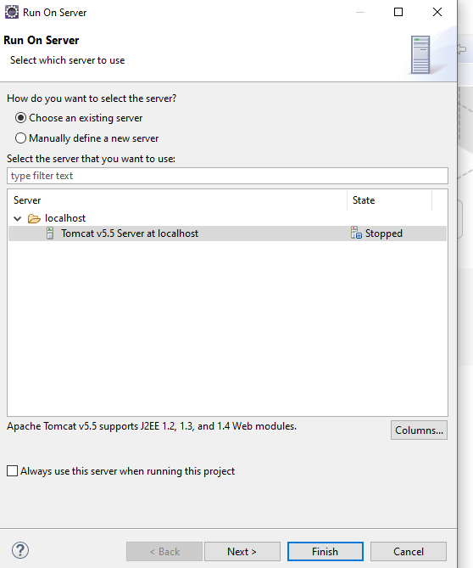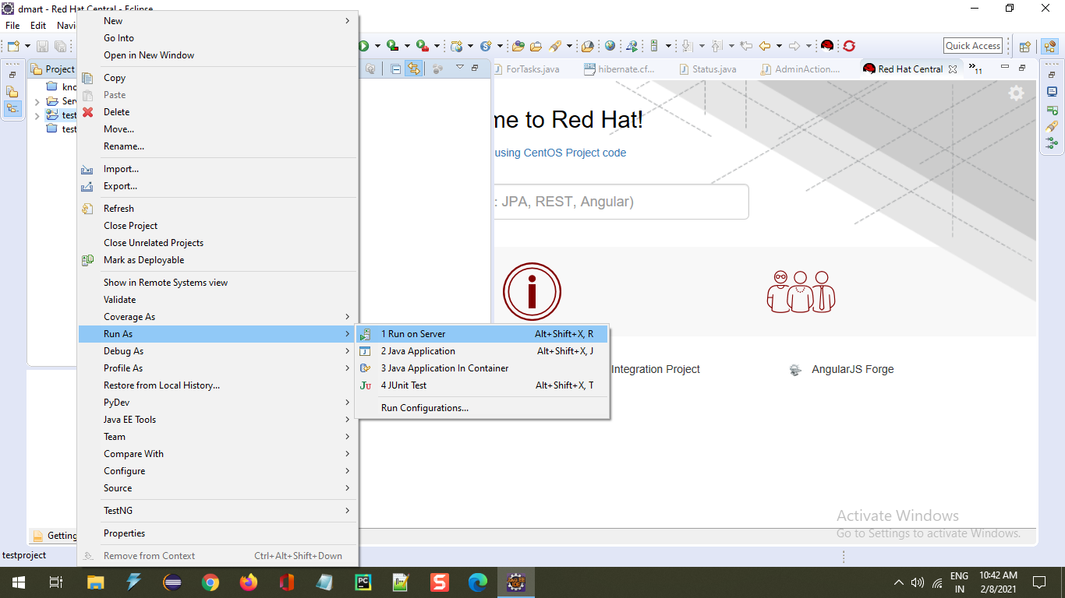

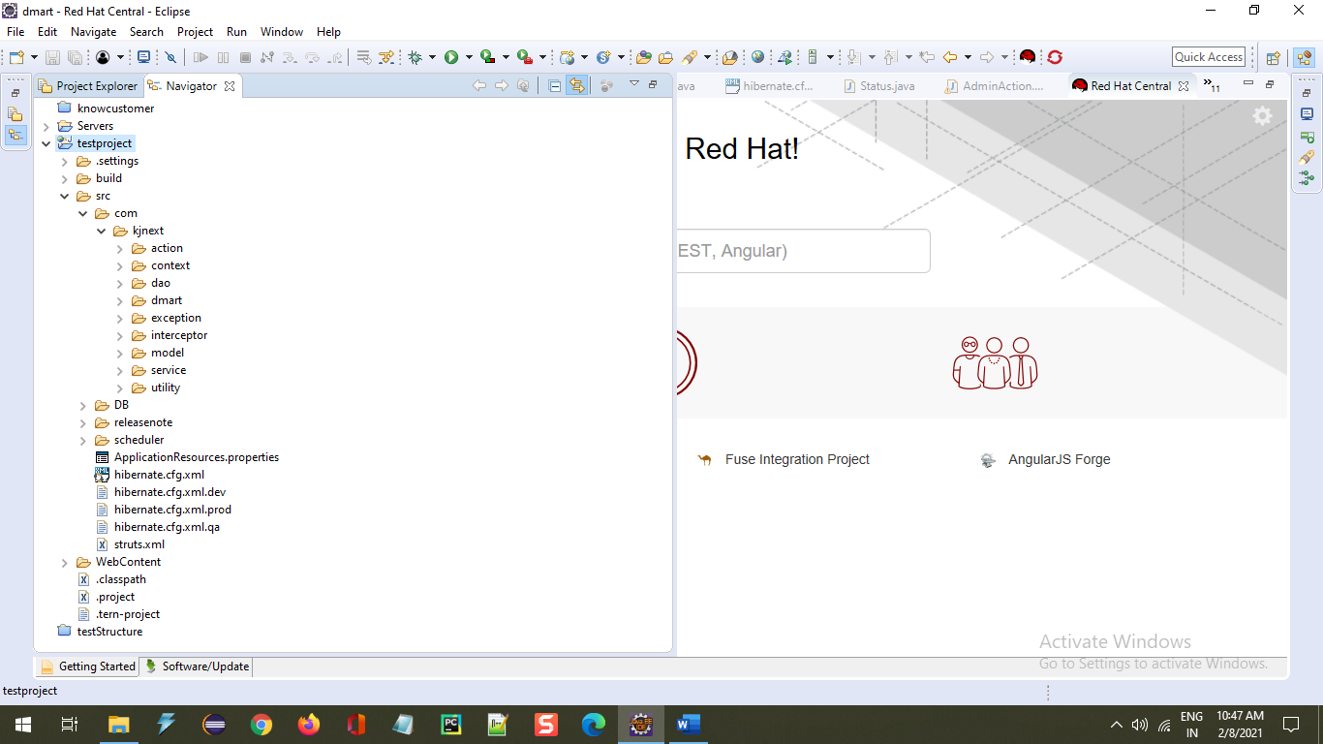

DB Script restore into your system



